Chapter 3

**METHODOLOGY**

This chapter discusses the concepts and processes on how to handle and provide the proposed system for Bolinao Tourism entitled, Tourism Monitoring System for Bolinao.

# Project Framework

The proponents will use the project framework for a better understanding of the project development that is shown in Table 1.

Table 1:

Input Process Output Framework Model

| **INPUT** | **PROCESS** | **OUTPUT** |
| --- | --- | --- |
| **Knowledge Requirements**   * Research on the background of the proposed study. * Review on related studies and literatures * Brainstorming   **Software Requirements**   * Identification of tools that will be used in the project (Microsoft Visual Code, Laravel PHP, Figma, Trello etc.)   **Hardware Requirements**   * Processor: Core i3/ Ryzen 3 * Disk space: 10 Gigabyte (GB) * Memory: 4 Gigabyte (GB) RAM * Network Interface Card with RJ-45 cables / Wi-Fi | **Initiation**   * Identify existing process in the system. * Identify user requirements. * Identify & Assign scrum roles.   **Planning and Estimation**   * Product Backlog Creation. * Sprint Initiation. * Initial Prototype and Design. * Create process workflow. * Scrum Board Creation.   **Implementation**   * Sprint Implementation. * Coding / Development of system. * Sprint Iterations.   **Reviewing**   * Scrum Meeting. * Testing of System. * Bug-fixes.   **Releasing**   * Deployment of the system. * (optional) Retrospective Meeting. | **Tourism Monitoring System for Bolinao**  **Tourism Monitoring System for Bolinao** |

By understanding the previous processes and activities of Bolinao Tourism, identifying the requirements and core data would help in development of the proposed system. Incorporation of tools required for data gathering, data analysis, and system development is done by the proponents especially the Trello Board collaborative tool to make sure that the proponents would be consistent in the system proposed. The proponents distinguished the programming language and frameworks that is useful for meeting the objectives of the study. The final course of the proponents leads to testing of the system process and create reviews for errors and bug-fixes.

# Project Design

Scrum is the recommended software methodology that the proponents has chosen for this study. Scrum is an Agile Development methodology that uses iterative and incremental processes to develop software. Scrum is an Agile framework that is designed to deliver value to the customer throughout the project's development. It is adaptable, fast, flexible, and effective. Scrum's main goal is to meet the needs of the customer by creating an environment of open communication, shared responsibility, and continuous improvement. The development process begins with a general idea of what needs to be built, followed by the creation of a list of characteristics ordered by priority (product backlog) that the product owner desires.

Scrum is carried out in short, periodic blocks called Sprints, which typically last two to four weeks and are used for feedback and reflection. Each Sprint is its own entity, delivering a complete result, a variant of the final product that must be delivered to the client with the least amount of effort possible when requested.

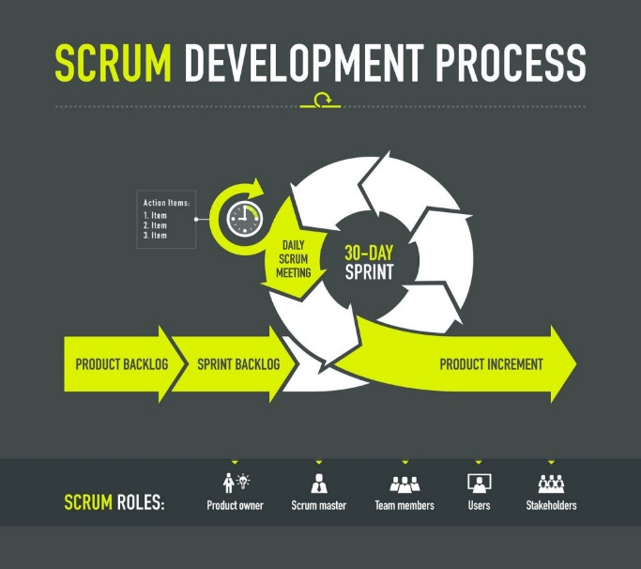Source:( <https://www.digite.com/agile/scrum-methodology/#scrum-process> )

Figure 1:

Scrum Model

The proponents used *Scrum Methodology* due to its nature of easier scalability. The model is innovative and experimental to the proponents which allows better focus on the definite functionalities of the proposed system. Scrum promotes a cross-functional team that is self-functioning which makes the proponents more efficient in handling tasks.

The model delivers shorter, separate projects that could help the proponents to test the system after the end of each Sprint. The proponents used the model for its flexibility to change which makes the proponents to adapt to changing requirements that the proposed system entails. The Scrum Model provides the following benefits to the proponents: (1) Flexibility and adaptability, (2) Creativity and Innovation, (3) Improved Product Quality; and (4) Stakeholder Satisfaction.

**Scrum 3-5-3 Structure**

The proponents followed the practice of 3-5-3 structure of the Scrum Methodology which is: 3 roles, 5 phases, and 3 artifacts.

**Roles in Scrum**

The proponents identified the following core roles based on the Scrum Methodology.

The Scrum Master.  The scrum master is the scrum development process's facilitator. The Scrum Master is responsible for keeping Scrum up to date, as well as providing coaching, mentoring, and training to the teams as needed.

The proponents discussed the responsibility of this core role in scrum and voted who will be the first Scrum Master. In the middle of the phases, rotation schedule for Scrum Master role was implemented.

Product Owner. Is the voice of the stakeholders/users. They communicate the project's vision to the scrum team, validate the benefits in stories that will be added to the Product Backlog, and prioritize them on a regular basis.

The proponents assigned the voice of the stakeholders is a representative of Tourism Office of Bolinao. Having assigned, the proponents then will discuss their role in the following phases of the development of the system.

The Scrum Team. Scrum team members self-administer tasks and share responsibility for meeting each sprint's objectives.

The proponents are the core scrum team of the project which had self-administer tasks to each other and further remind responsibilities assigned, perform scrum meetings, and communicate with the team actively.

**Scrum Phases**

Initiation. It is where vision for the system is created. This includes important points like noting who the project's stakeholders are and assigning the roles to the team. Epics will be identified and broken down into User Stories.

In this phase, core roles were assigned in accordance with the methodology. In addition, a proper workplan and a Gantt chart was created in this phase to identify the tasks and schedules that the proponents need. The proponents used the gathered information based on the interview in the Bolinao Tourism Office to produce the product backlog which is the required knowledge, tools, and functionalities of the proposed system. The following event result for the creation of sprint backlog. Trello Board was used by the proponents to make sure the phases were being followed consistently. The proponents also incorporated GitHub to generate a consistent backlog of every sprints.

Planning and Estimation. During this phase, creation of sprints is done for effective collaboration. Completed sprints can then be combined later to complete all necessary elements in the product/sprint backlog. Estimation of time of delivery can also be created in this phase. This phase is iterative until the end phase.

The proponents created sprints based on the optimal sprint duration which is 2 - 4 weeks per sprint. These sprints were simulated by the proponents using GitHub and by making sure that the core members have the right repositories for the system. Iterative prototypes were designed and incorporated by the proponents to further support user stories embedded in the planned sprints. Multiple sprints were combined when needed by the proponents. In addition, the proponents created iterative flowcharts and use case diagrams that will be included in user stories to further emphasize the goals of each functionality in the system proposed. Iterations were made by the proponents in the following sprints created based on the sprint backlogs.

Implementation. It is the phase when the team implements the sprints planned. During this phase, updated backlog, cleaning of completed items, assigning new items from the backlog is maintained by the core members as needed. Daily scrum meeting is also being done in this phase to provide updates and review product owner’s concern. This phase can also be repeated until the end of the phase.

The proponents pushed the sprints that was planned in the previous phase where backlogs are also updated whenever is possible. These steps were simulated by using Trello for the sprints and stories. Pulling of backlogs was made from Trello while pushing of the created sprints were done through GitHub by the proponents. Scrum meeting is done by the proponents together with the stakeholders to provide updates and address concerns to the development of the system and features.

Reviewing. Feedbacks are being gathered in this phase through review meeting with the team to discuss the sprint. In addition, this phase provides time to assess areas for improvement based on the results of the completed sprints. Adjustments of process and procedures is being done in this phase to successfully transition into the next sprint. This phase is repeatable like the previous phases: planning, estimation, and implementation steps.

During this phase, the proponents continuously employed scrum meetings to gather feedbacks and discuss the current updates of the developed system. The proponents made UI adjustments, bug-fixes, sprint backlog creation, and iterations in this phase based on the feedbacks gathered in the meeting.

Releasing. The last phase is where delivering of the finished product to the stakeholders is done. This phase would also give chance for retrospective meeting to discuss the overall performance of each phases done.

During this phase the proponents completed the necessary reviews, iteration, and testing for the system. The proponents would then demonstrate how to use the system and present it to the stakeholders. The respondents will ask for a feedback and evaluations on the testing that will take place.

**Scrum Artifacts**

Product Backlog. It is the list that collects everything the system needs to satisfy the stakeholders and users. It is prepared by the product owner and functions are prioritized based on its importance in the system feature.

The proponents gathered the backlogs from the assigned product owner through interviews and email to be able to identify the system functions that requires prior focus. Additionally, the backlog also made through the functions observed in the current website of Bolinao Tourism.

Sprint Backlog.  It is a subset of the product backlog items chosen by the scrum team to be completed during the sprint on which would be worked on.

The proponents used Trello Board collaborative tool to create the sprint backlogs during the sprint by creating Workspace and Boards. Additionally, these backlogs are simulated in a separate repository in GitHub for transparency.

Increments. The increment is the sum of all tasks, use cases, user stories, product backlogs, and any other element developed during the sprint and made available to the end-users.

The proponents continue to sum all epics, user stories, product backlogs, etc. in the form of cards to form the increments in the created Workspace in Trello Board, after these cards are finished, commits are being pushed in the repositories to update the latest sprints.

# Population and Locale of the Study

The proponents obtained information from a representative of the Bolinao Tourism Office. The respondents were the primary data source for the study. The proponents will use interviews and observations to acquire key data and information to identify and assess flaws with the current system, as well as to determine what system needs and features will be included in the proposed system.

Subjective Sampling method was used for identifying the required respondents that would contribute to the finalization of the study.

Most of these respondents will be the end-users of the proposed system. The remaining respondents will be the faculty members of the Information Technology Department of Pangasinan State University Alaminos City Campus. Respondents in the locale were subjectively chosen including LGU Tourism Officers. The subjectively chosen respondents will aid the proponents in validating the system for user acceptability.

The following table will be the respondents of the acceptability survey:

Table 2:

Respondents of the Study

|  |  |
| --- | --- |
| **Respondents** | **Number of Respondents** |
| Locale | 25 |
| End-users | 25 |
| Tourist Officers of LGU in Bolinao | 2 |
| PSU – Alaminos City Campus IT Instructors | 3 |
| Total | 55 |

The proponents subjectively chosen 25 respondents in the locale. In addition, 25 end-users were arbitrarily chosen to provide subjective feedback on the proposed system. 3 faculty members of the IT Department of PSU Alaminos City Campus that is good in judgement based on transparency, and experience in system testing. The proponents also have 2 respondents in the Tourism Office of Bolinao which is: (a)a representative of normal position; and (b) a representative IT officer.

The proponents also used a variety of reference materials in the development of the proposed system, including online research and publications, journals, articles from the internet, reading related literature, and other related studies from the internet.

# Data Instrumentation

The following data instrumentation will be used by the proponents for gathering data needed for the development of the proposed system.

Unstructured Interview. An unstructured interview is a data collection method that relies on asking participants questions to gather information about a topic. Unstructured interviews, also known as non-directive interviewing, do not follow a set pattern and do not have questions pre-arranged.

The proponents prepared an interview with a representative of the Tourism Office of Bolinao. The information gathered will serve as the foundation for the product backlogs and development of the system.

Online/Internet Research.Online search is the latest tool in data gathering and collection of data for the study.

The proponents gathered data and information related to the study by visiting different related articles and by searching for any studies that can help develop the system.

Interview.An interview is a structured conversation in which one person asks questions and the other responds.

The proponents prepared an interview guide that will be used in an interview with a representative at the Tourism Office of Bolinao.

All questions satisfied by the respondent will be used for data gathering and for deploying the foundation of the system proposed.

Survey.It is the gathering of information from a sample of people based on their responses to questions.

The proponents prepared a set of survey questions that will be used in a sample of people. The data gathered by the proponents will be used to add and/or remove features in the system that is needed.

Document Review.This is a method of analyzing and reviewing documents such as records, manuals, and other types of documents.

The proponents carefully reviewed related documents that are related to the system. It will be in the form of studies and theses from the previous year’s found at the library of Pangasinan State University - Alaminos City Campus. This gave the proponents the potent data needed in the development of the study - its features.

# Tools for Data Analysis

Flowchart.It is a type of diagram that can be used in supporting studies that typically represents an algorithm, workflow, or process and depicts a step by connecting shapes of various types with arrows.

The proponents created a flowchart that will help in breaking the development down into small tasks. The proponents used this tool to better understand the steps taken in recording tourists/guests’ data in the Tourism Office of Bolinao.

This can help the proponents in organizing data in an orderly manner for backlog creations.

Entity Relationship Diagram. It is a type of flowchart that depicts how "entities" such as people, objects, or concepts interact within a system.

This tool was used by the proponents to identify the core entities in the system. This tool was utilized by the proponents to better visualize the interaction between the entities of the system.

Use-Case Diagram. It is a set of actions and steps that the users and the system take to accomplish a goal. The system requirements are identified, organized, and clarified by users.

The proponents used this tool to expand their understanding within relation to user interaction of the system and to better implement the steps taken to finish a task or actions.

Weighted mean. The proponents use the weighted mean to determine what is the average number of respondents that takes the survey for the proposed Record Management System.

Formula

Where:

= mean

x = number of respondents

w = weight

n = total number of respondents

Source: Amid, D.M. (2009) Fundamentals of STATISTICS

Likert Scale. The proponents will use a scale of measurement called Likert Scale to assess the proposed system's acceptability.

Table 3 will depict the proposed system's measurement scale

Table 3:

Likert Scale

|  |  |  |
| --- | --- | --- |
| **Scale** | **Range** | **Descriptive Rating** |
| 4 | 3.26 – 4.00 | Acceptable |
| 3 | 2.51 – 3.25 | Slightly Acceptable |
| 2 | 1.76 – 2.50 | Slightly Unacceptable |
| 1 | 1.00 – 1.75 | Unacceptable |

# 

# Tools for System Development

These are the following tools that will help the proponents to fully develop the proposed system:

Figma.It is a vector graphics editor and prototyping tool which is primarily web-based, with additional offline features enabled by desktop applications for macOS and Windows. The Figma mobile app for Android and iOS allows viewing and interacting with Figma prototypes in real-time mobile devices.

The proponents used the web application to create a semi-interactive prototype to visualize the functions based on the product backlogs.

Trello Board.It is a collaboration tool that is available on the web that can help organize projects into boards. Trello tells what's being worked on, who's working on what, and where something is in a process. It is a digital white board, filled with lists of sticky notes, with each note as a task for the designated individual in the team.

The proponents utilized this tool to better organize the development of the system and to prevent miscommunication in tasks assigned. This is the main foundation that the proponents will use for the scrum board.

GitHub Desktop. GitHub Desktop is used by groups or teams to collaborate using best practices with Git and GitHub. It can be used to complete most Git commands from the desktop with visual confirmation of changes. Features are push to, pull from, and clone remote repositories with GitHub Desktop, and use collaborative tools such as attributing commits and creating pull requests.

The proponents utilized this collaborative tool to make the documentation and development of the system more organized professionally. The proponents used this tool to see the progress and changes of both the documentation and the system.

Microsoft Visual Studio Code. An open-source integrated development environment (IDE), it is a creative launching pad that users can use to edit, debug, and build code, and then publish an app.

The proponents utilized this IDE to develop the proposed system, Tourism Monitoring System for Bolinao. Additional Plugins have been incorporated that helped the proponents develop and debug the system efficiently.

Laravel PHP Framework.Laravel is a free, open-source PHP web framework that is based on Symfony and is intended for the development of web applications.

The proponents used the Laravel PHP Framework as the base for the web system.

XAMPP.XAMPP is a free and open-source cross-platform web server solution stack package that includes the Apache HTTP Server, the MariaDB database, and interpreters for PHP and Perl scripts.

The proponents used XAMPP in creating the database for the system.

# Description of Initial Prototype

Figure 2:

Initial Landing Page

Prototyping is an iterative process in which design teams turn abstract concepts into tangible forms, ranging from paper to digital. The proponent creates a prototype to visualize and demonstrate the proposed system to the project sponsor. The following figures illustrate the initial prototype provided by the proponents.

Figure 3:

Initial Login Page

The Landing Page is the first page that will show up upon entering the webpage. It shows the overview of the web app.

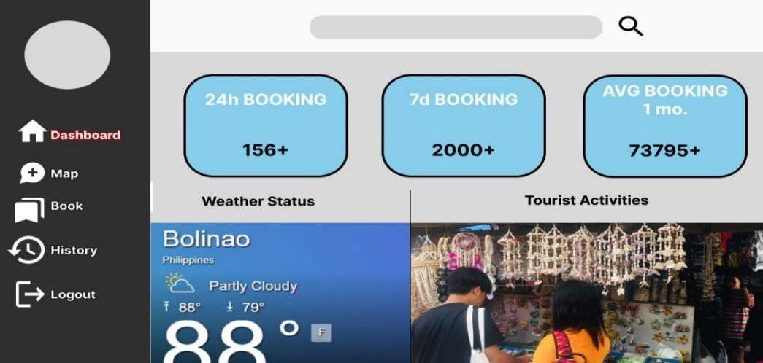

Figure 4:

Initial Dashboard

The Login Page is the page shown when clicked Login in the Landing page. It is where users will login to access system features in the web app.

Dashboard is the page shown to the user where user activities are show including a real-time weather monitoring. Users will be able to see the daily, weekly, and average booking activities in the webpage.

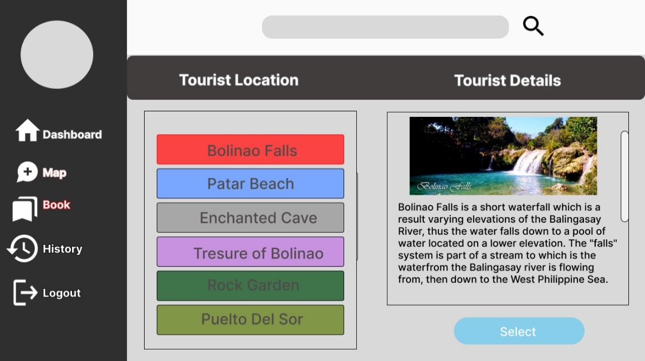

Figure 5:

Initial Booking Page

Booking Page is the page shown when users will book to their chosen tourist location. Pictures are shown to the users with short description of this selected tourist spots.

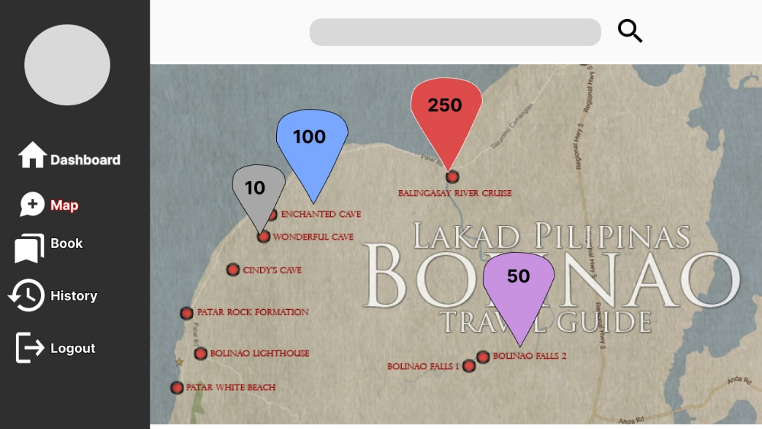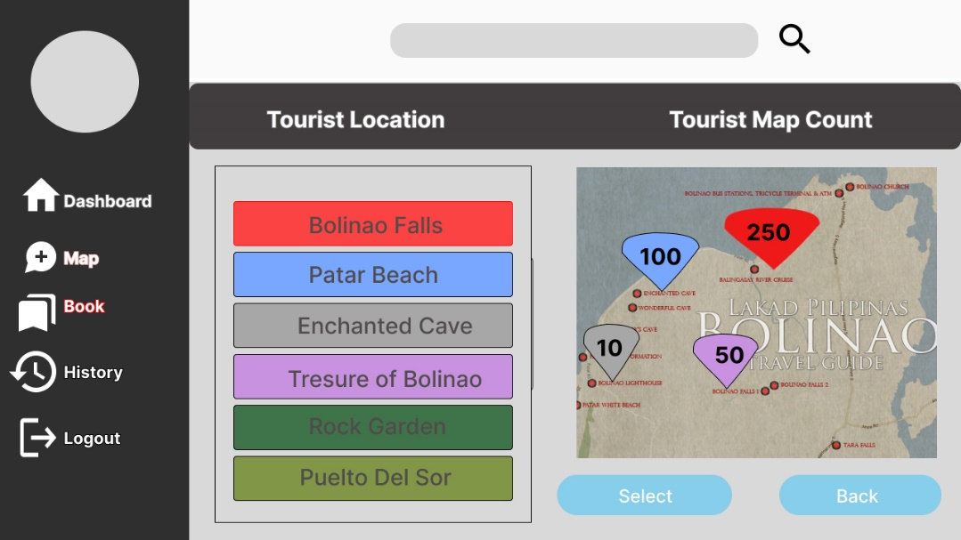 The Map page will show the real-time monitoring feature of the system where users will be able to see the current numbers of users/guests that booked in a specific tourist spot in the locale.

Figure 7:

Full-screen Map

Figure 6:

Initial Map

# The Proposed Implementation Plan

The proponents created an implementation plan prior to the completion of the system. The completed Tourism Monitoring System will be deployed to the target locale’s Tourism Office for testing.

This will satisfy the objectives of the proponents while also considering that this deployment must be carefully done to not disrupt any actions or activities being held in the Tourism Office.

Having prepared the web app, the proponents will need to locate and mark the equipment per approval of the organizations and test the operability of the completed system.

The recommended computer requirements for the implemented system are the following:

* Operating System: Windows 7 / 8 / 8.1 / 10 / 11
* Processor: Core i3 / Ryzen 3
* Disk space: 10 Gigabyte (GB)
* Memory: 4 Gigabyte (GB) RAM
* Network Interface Card with RJ-45 cables / Wi-Fi options.

After the equipment that the proponents will install in the system is physically set up, the testing procedure will begin.

The proponents will determine the setup is suitable, and personnel from the Tourism Office of the LGU of Bolinao will be trained on the new system.

Table 4:

Implementation Plan

|  |  |  |  |
| --- | --- | --- | --- |
| **Strategy** | **Activity** | **Persons involved** | **Duration** |
| * Approval of the organization | * System proposal to the organization | * Proponents, * Project sponsor | 1 day |
| * System Installation | * System installation including prerequisite software and hardware | * Proponents | 4 hours |
| * Information Distribution | * Training and Manual(pdf) | * Proponents, * End User | 1 day |
| * User Training | * Hands-on training and a brief lecture | * Proponents, * End User | 1 day |

The implementation Plan table shows the steps on how the system will be implemented. It also displays the strategy, activity, people involved, and duration of a particular activity.